Project description:

My project is a useful tool to takes foods and its weight to calculated the day’s nutrition consumption. The program will input personal information file, read the information and store them to variables. The information can be further used by the program. After input user’s weight information, the welcome screen will be printed, and the program can calculate daily nutrition recommended goal based on the weight and amount of nutrition per unit body weight. This program only focuses on protein, carbohydrate and vegetable. The program will ask the user to enter protein and carbohydrate in grams per kg of body weight, or the user can just enter 0 to get the default value. Then, the program will ask user to enter food name and weight of the food. This part is in a while loop, the program will keep asking the user to enter food name and food’s weight until the user enter END. Also, the program has functions acting like foods library. When the user enters a food name for the first time, the program will ask the user to enter the nutrition facts, for example, the user enter “chicken” for the first time, the program will ask the user to enter protein and carbohydrate in grams per 100g of chicken. After the user entered the information about chicken, he or she can just enter chicken and weight of chicken without entering protein and carbohydrate in grams per 100g again. All protein and carbohydrate eaten will be calculated and stored in a list for calculating the total consumption. After this part, the program will calculate the total nutrition consumption, all information needed will be written in the report with today’s date as part of the file name. Finally, the data stored in food dictionaries will be written in .txt file for everlasting storage. When the user run the program next time, the program will read the data storage files and import saved information into the program before input any food name and weight.

This tool is useful, because it offers a method to record daily diet. For people who trying to change their body figure or improve their health condition, tracing diet is very helpful. They can set a nutrition goal and modify their diet to achieve the goal. Also, people may find out which food make them gaining weight or losing weight.

How to run:

1. Before running the program, we should know where will be the reports, where will the data be stored and what is the report looks like. Are several files in the folder. Library_c.txt, library_fl.txt and library_p.txt store data about food nutrition facts. Library_c.txt and library_p.txt store food name and nutrition facts in number with specific format and the library_fl.txt only store food names.



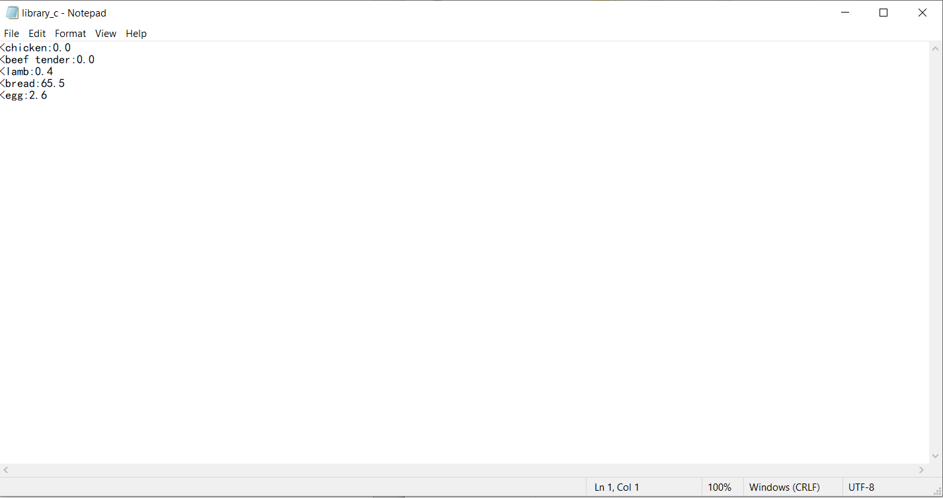

The program will generate a report in .txt file which has today’s date as part of the name. For example, there are two files generated by the program on 2020-12-02 and 2020-125-03:



1. Press F5 to run the program, the program will show:



The program asks the user to enter the name for personal information file. In the folder, there is a test file named personalinforamtion.txt can be used in this step:



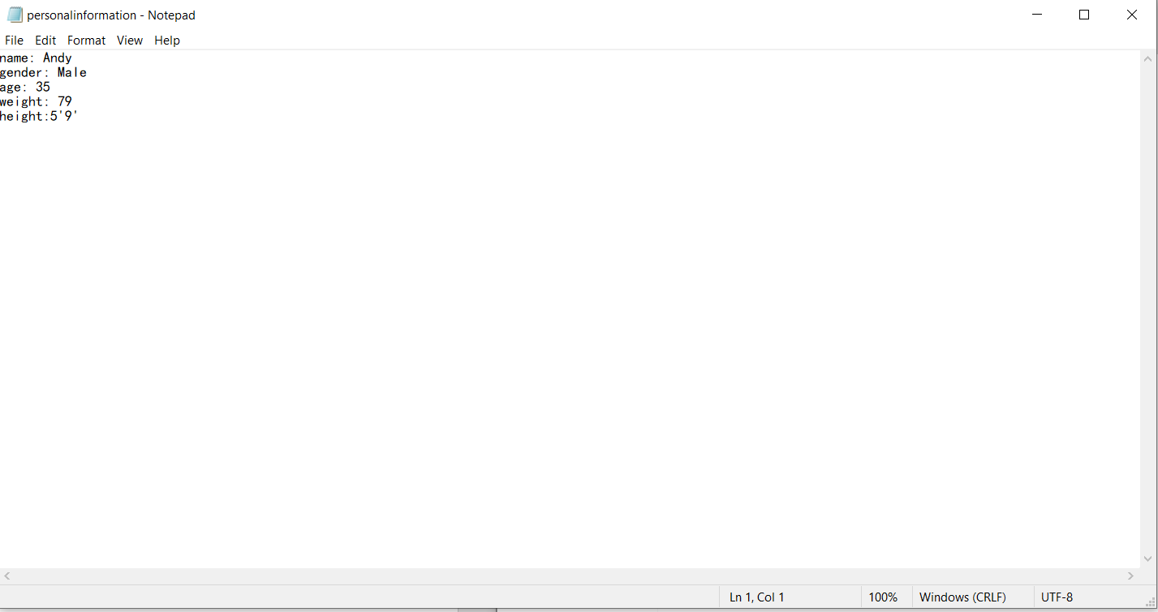

The user can change the information in the file without changing the format. For example, the user can change *name: Andy* to *name: Bob.* For this step, personal information will be imported.

1. After the personal information file is correctly imported, the program will print the welcome screen with name, weight and date. Then, the program will ask user to enter nutrition goal.

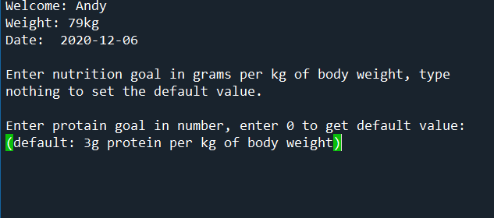

The user will be allowed to enter number (either integer or decimal) in grams per kg of body, the user can enter 0 to set default number which is 3 for protein.



Next is for carbohydrate which is similar to protein. After the protein and carbohydrate goal is correctly entered, the program will print the total amount of nutrition for this day:

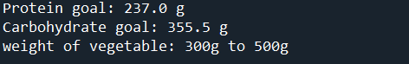

1. The next step will be entering foods and weight. the program will ask the user to enter food name and weight. if the food is vegetable, the user can just type “vegetable”.

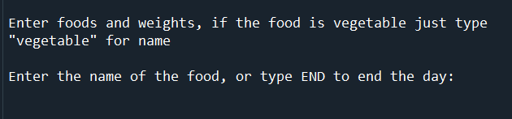

If the food name is not in the storage, the program will ask user to enter nutrition information of the food.

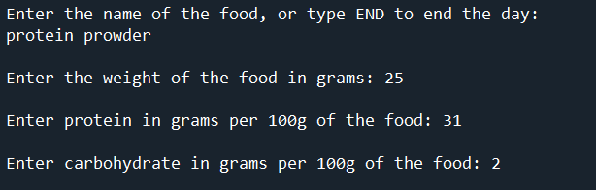

The program will keep asking the user to enter food name and weight until the user enter END to terminate this process.

1. Finally, after entered END the program will stop. All result will be written in the report. If the user opens the report, he or she can find the result in it.

This is an example of the report:

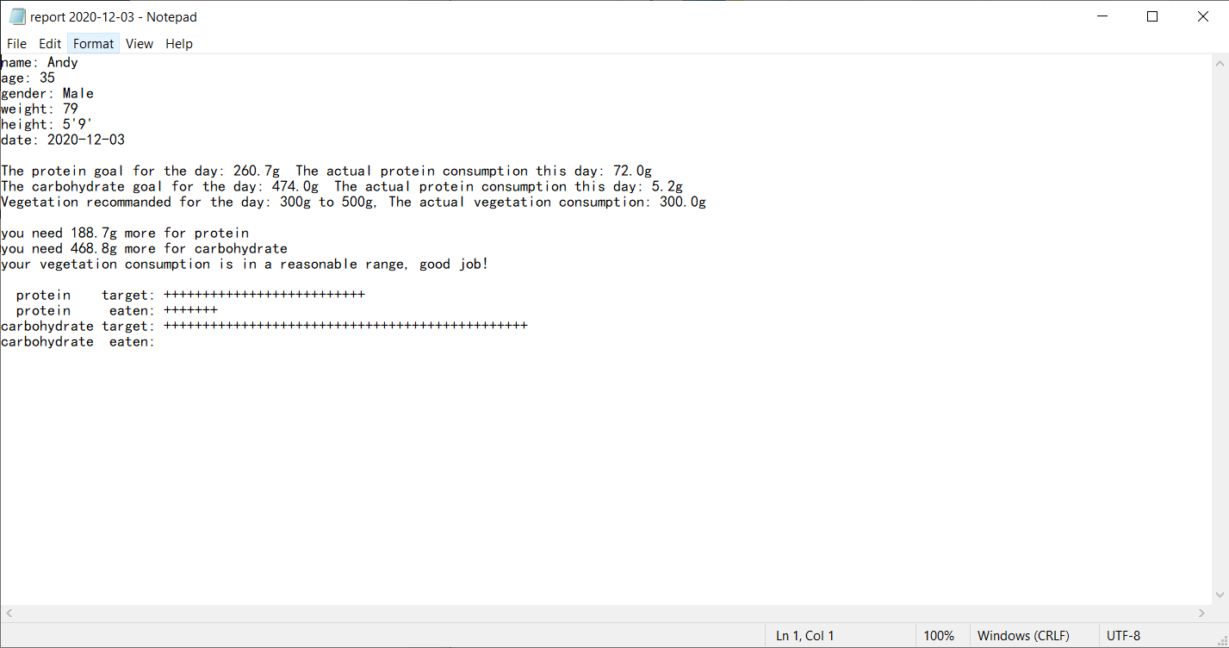

Beside the report, the program will print examples of build-in functions which can do works such as checking the personal information or food library.

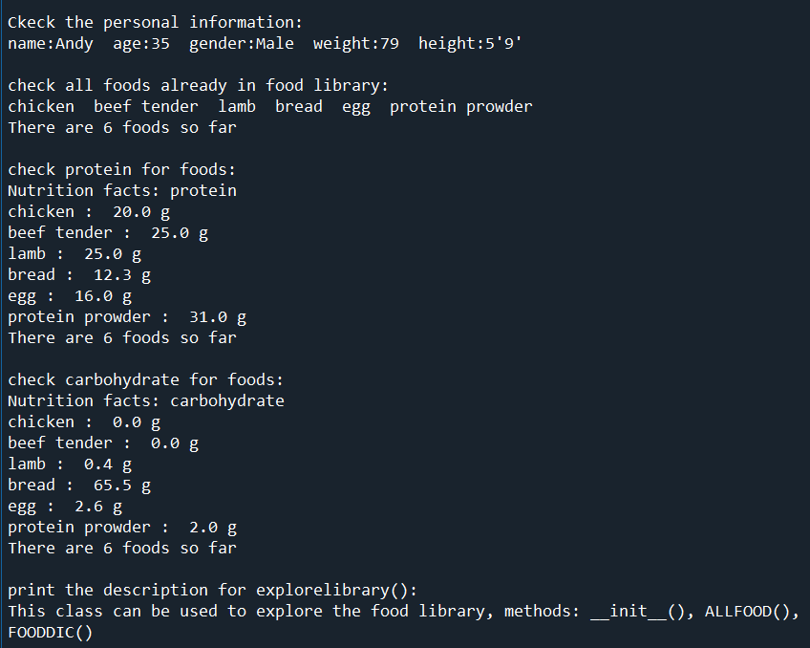

Illegal execution:

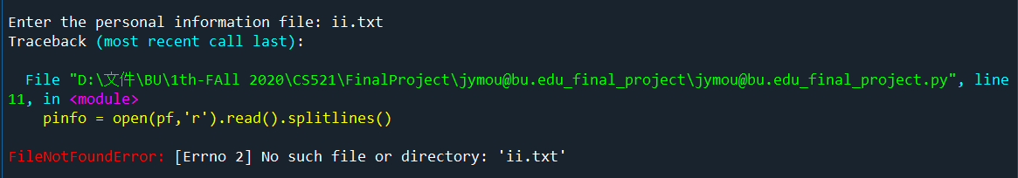

The personal information file must in the same folder with the code. If the code can’t find any file with the name entered by the user, it will show error.



The input for protein and carbohydrate goal must be a number, either integer or decimal. In this case, I entered “ak” which is not acceptable for this part, the program will print an error message and ask the user to enter again.

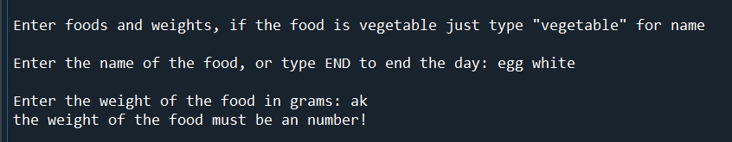

When the program asks the user to enter foods, the food name can be anything, but the weight is required to be number. I entered “ak” which is not acceptable, the program asks the user to enter a valid input after print the error message.

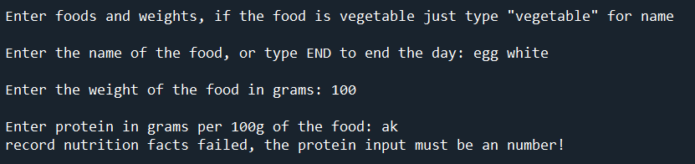

The same will happen when input nutrition facts.

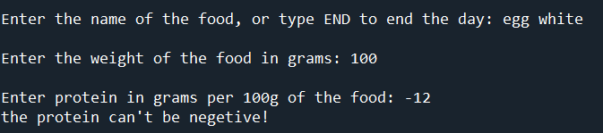

The program will also check the range of the input.

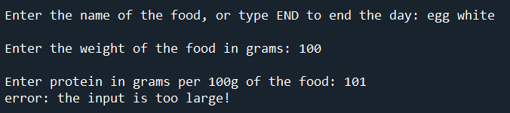

The input can’t be too large for nutrition facts. No food of 100g of weight can have more than 100g protein.